The University of Azad Jammu and Kashmir, Muzaffarabad

Name: Alishba Zakir
Roll No: 2024-SE-02
Course: DataBase Systems
Course Code: CS-2204
Lab: 12
Submitted To: Engr. Awais Rathore
Submitted By: Alishba Zakir
Date:June , 2026

Department Of Software Engineering
LAB REPORT: LAB #4
AGGREGATE FUNCTIONS
Part A — Whole-Table Aggregates & COUNT Variations
Task A1: Count the total number of customers, products, and orders in the database.
SELECT
(SELECT COUNT(*) FROM Customer) AS TotalCustomers,
(SELECT COUNT(*) FROM Product) AS TotalProducts,
(SELECT COUNT(*) FROM OrderItem) AS TotalOrders;
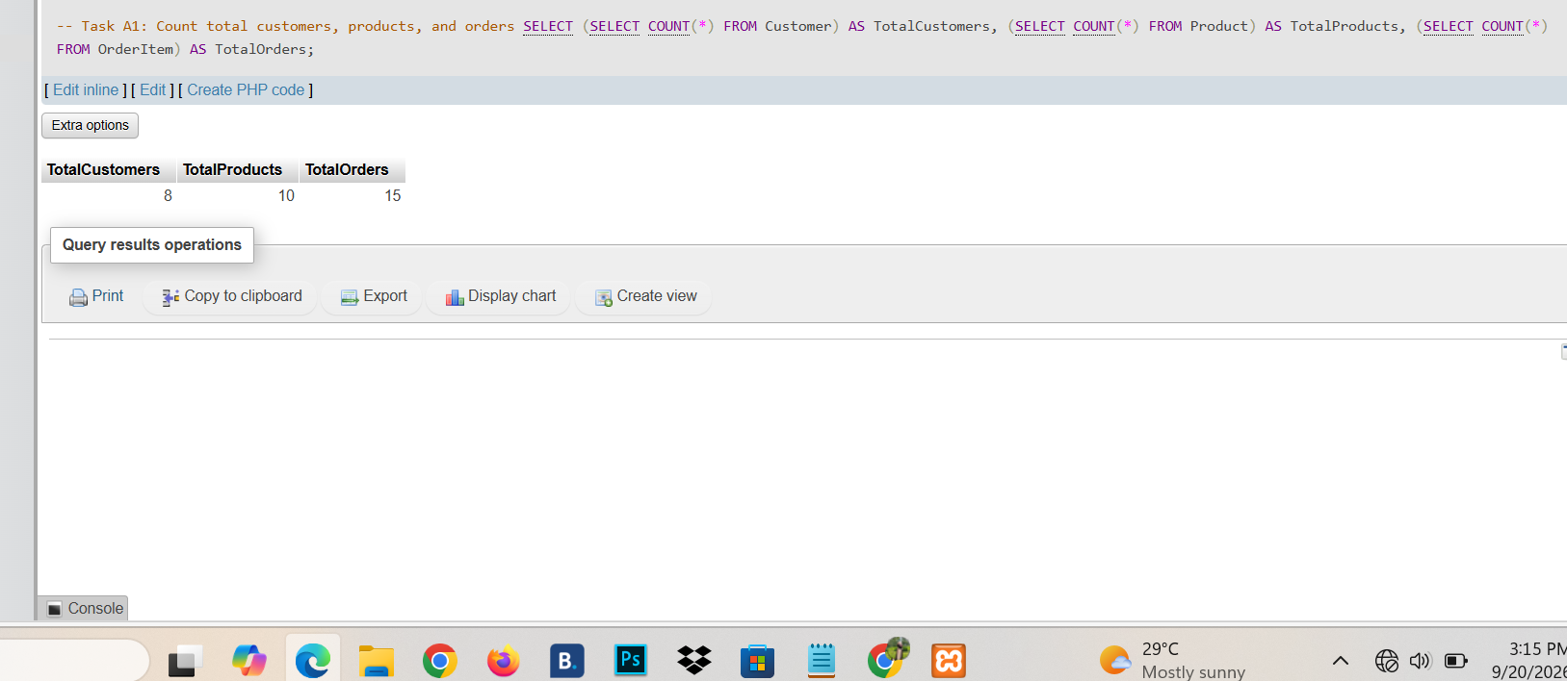
Task A2: Find the cheapest and most expensive products. Show MinPrice and MaxPrice.
SELECT MIN(Price) AS MinPrice, MAX(Price) AS MaxPrice FROM Product;
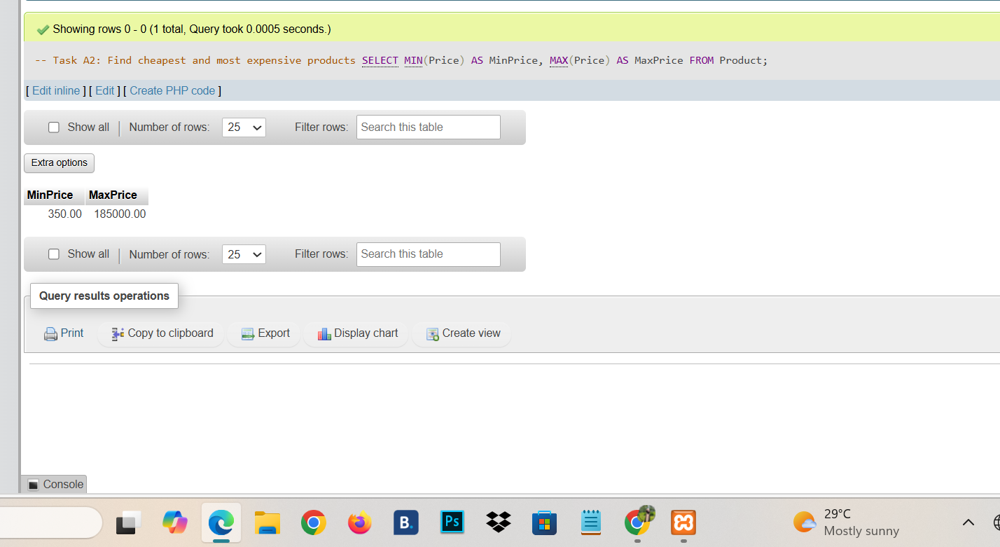
Task A3: What is the average price of all products? Round to 2 decimal places.
SELECT ROUND(AVG(Price), 2) AS AvgPrice FROM Product;
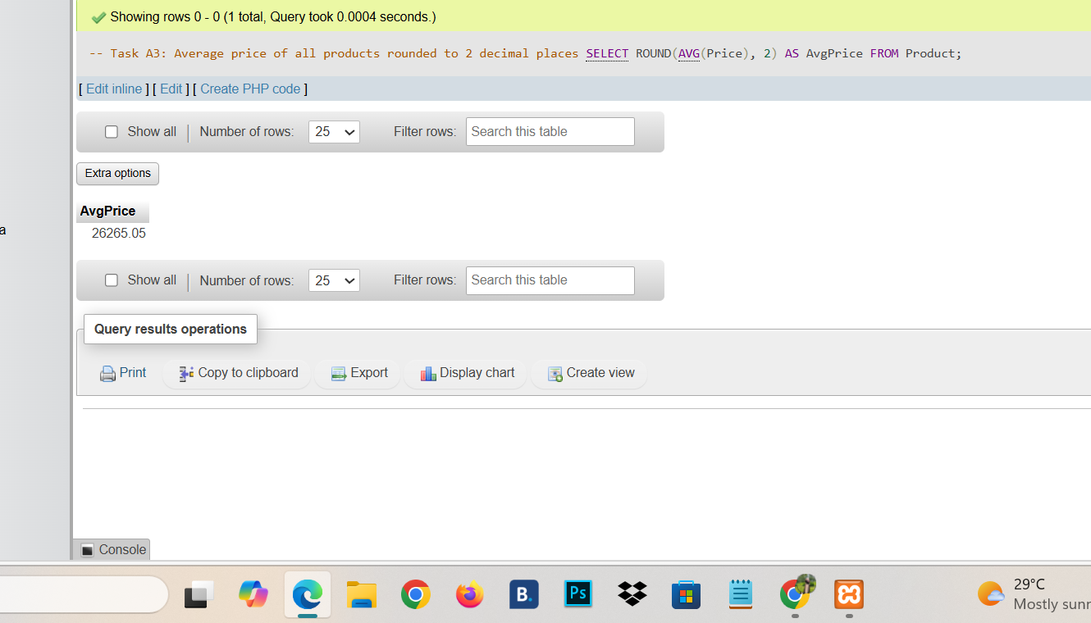
Task A4: What is the total stock quantity across all products?
SELECT SUM(StockQty) AS TotalStock FROM Product;
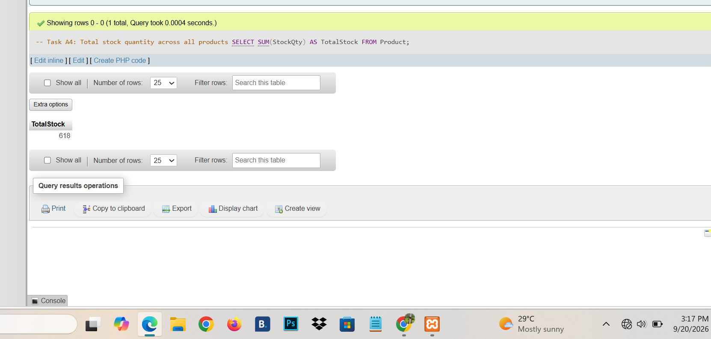
Task A5: How many distinct cities do customers live in (ignoring NULL)?
SELECT COUNT(DISTINCT City) AS DistinctCities FROM Customer;
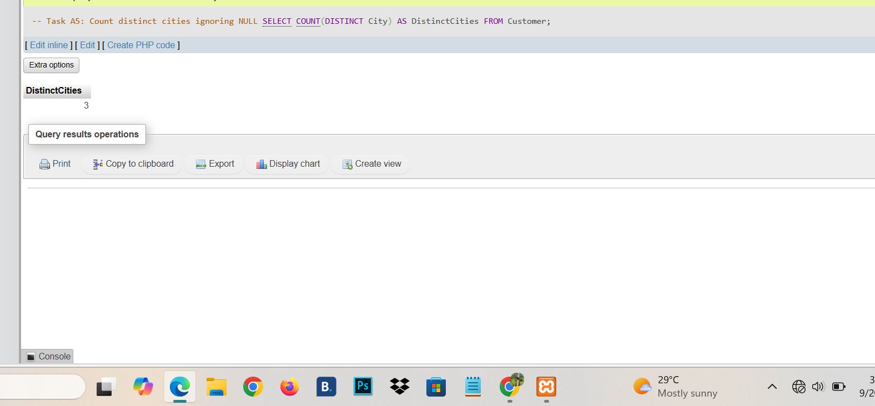
Task A6: How many distinct categories of products are there?
SELECT COUNT(DISTINCT Category) AS DistinctCategories FROM Product;
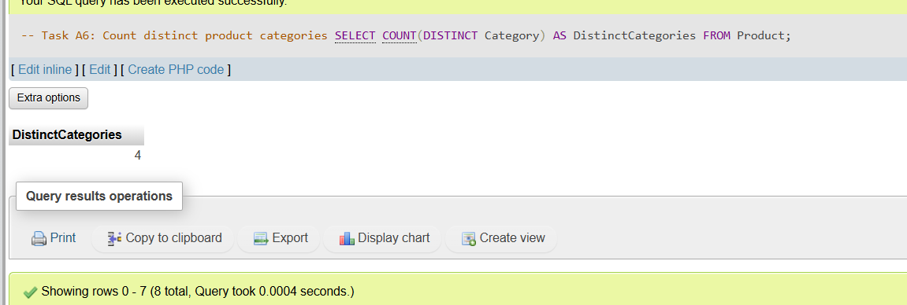
Task A7: How many customers have a recorded city? How many do not? (Two queries)
-- Query 1: Recorded
SELECT COUNT(*) AS HasCity FROM Customer WHERE City IS NOT NULL;
-- Query 2: Not recorded
SELECT COUNT(*) AS NoCity FROM Customer WHERE City IS NULL;
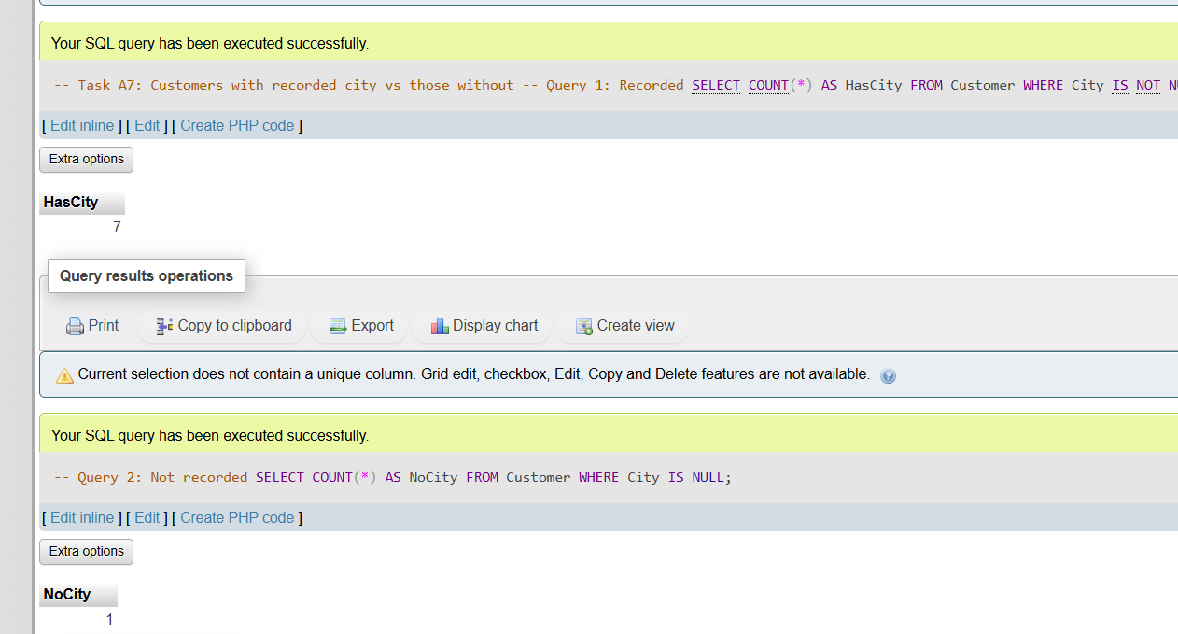
Task A8: Find the earliest and latest order date in the system.
SELECT MIN(OrderDate) AS EarliestOrder, MAX(OrderDate) AS LatestOrder FROM OrderItem;
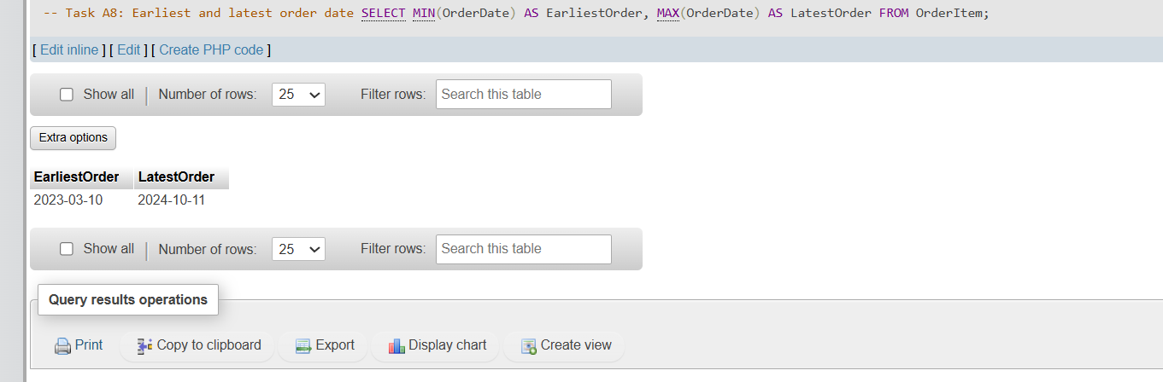
Task A9: Compute the total revenue from all orders. Revenue per row = Quantity * Price.
SELECT SUM(o.Quantity * p.Price) AS TotalRevenue
FROM OrderItem o
JOIN Product p ON o.ProdID = p.ProdID;
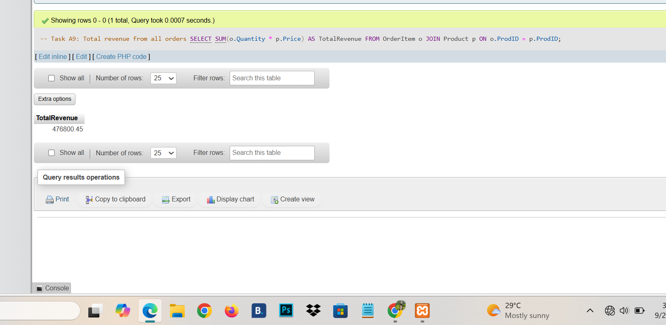
Task A10: Compute the average quantity per order (average of Quantity column). Round to 2 decimals.
SELECT ROUND(AVG(Quantity), 2) AS AvgQuantityPerOrder FROM OrderItem;
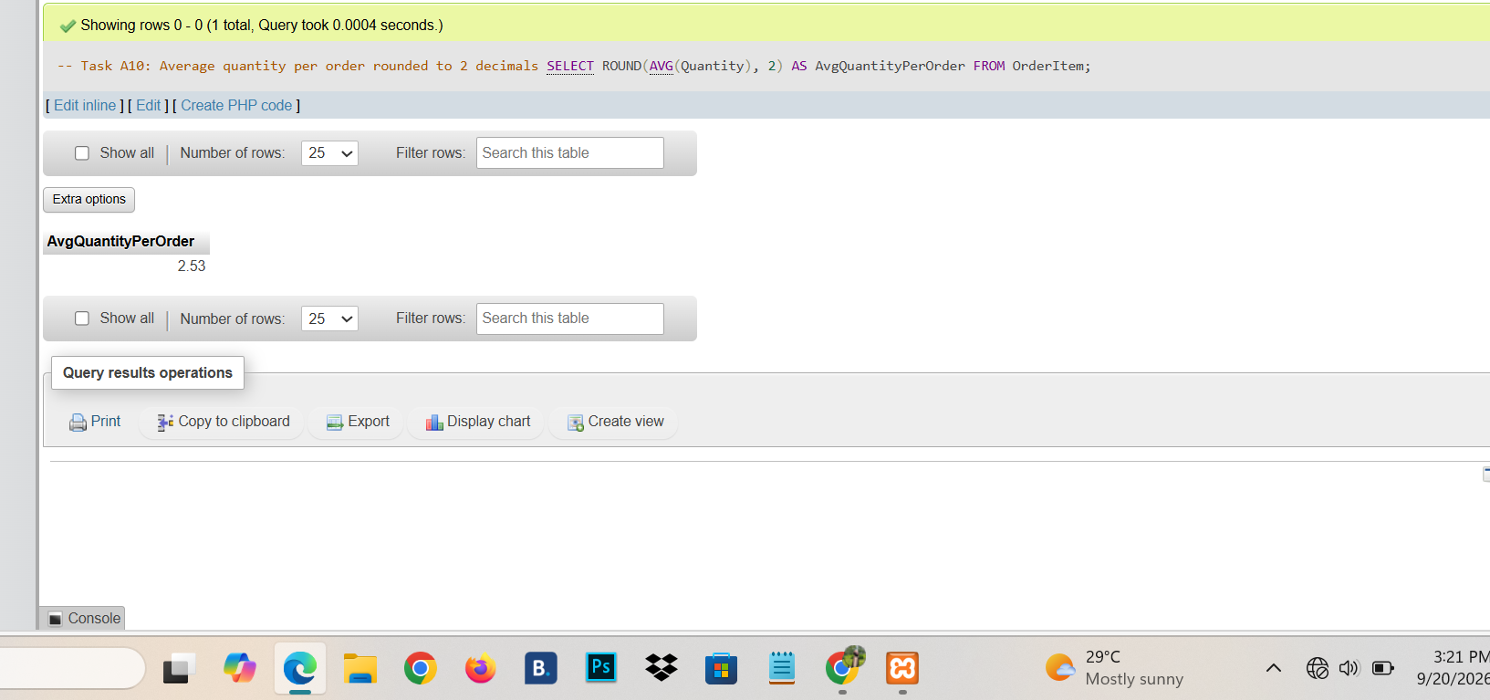

3. Part B — GROUP BY, HAVING, and Aggregates with JOINs
Task B1: Number of customers in each city. Sort by count descending.
SELECT City, COUNT(*) AS NumCustomers FROM Customer GROUP BY City ORDER BY NumCustomers DESC;
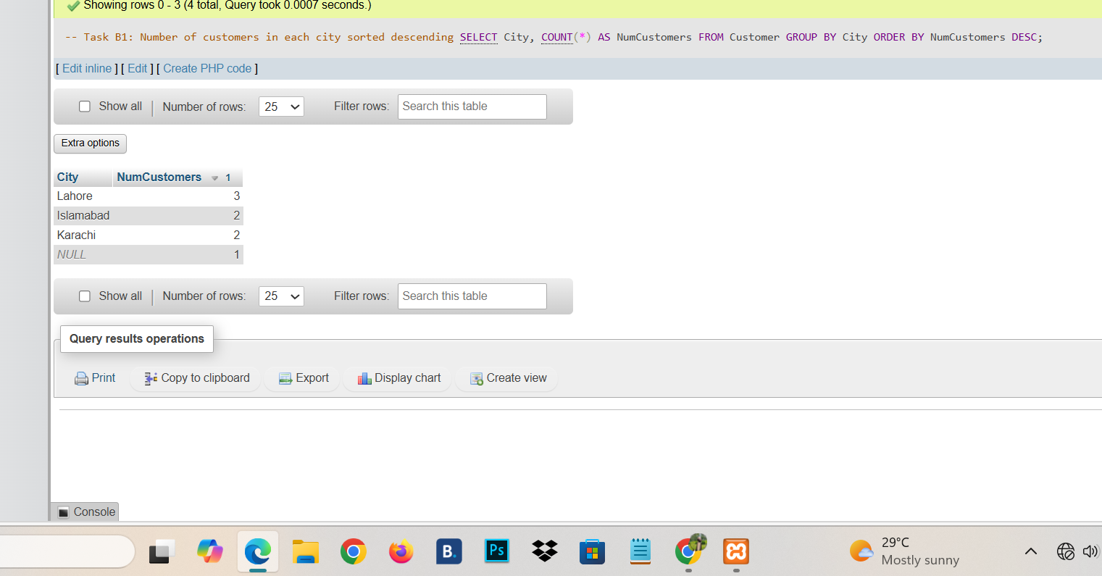
Task B2: Number of products in each category. Sort by count descending.
SELECT Category, COUNT(*) AS NumProducts FROM Product GROUP BY Category ORDER BY NumProducts DESC;
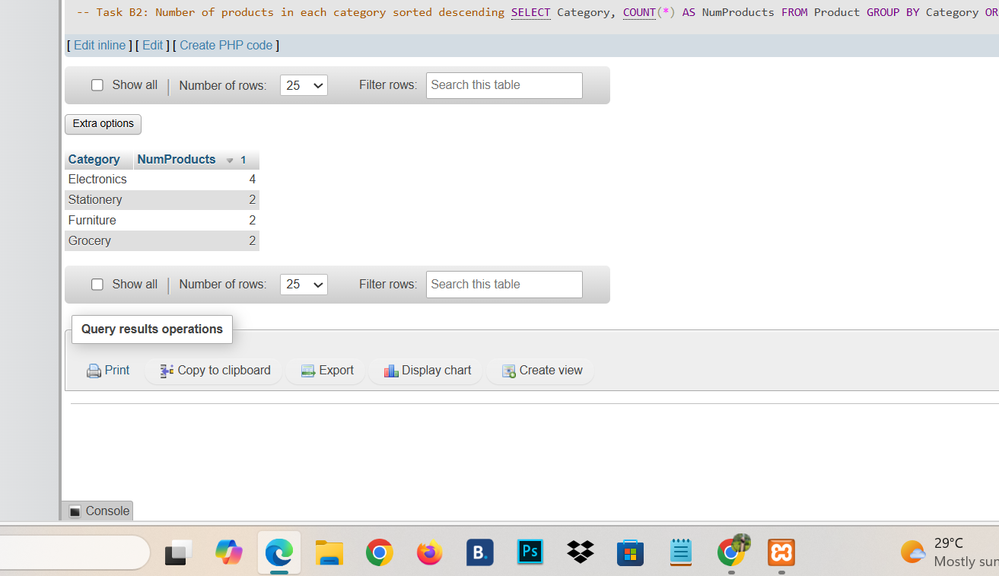
Task B3: For each product category, find the average, minimum, and maximum price. Sort by average price descending.
SELECT Category, ROUND(AVG(Price), 2) AS AvgPrice, MIN(Price) AS MinPrice, MAX(Price) AS MaxPrice
FROM Product GROUP BY Category ORDER BY AvgPrice DESC;
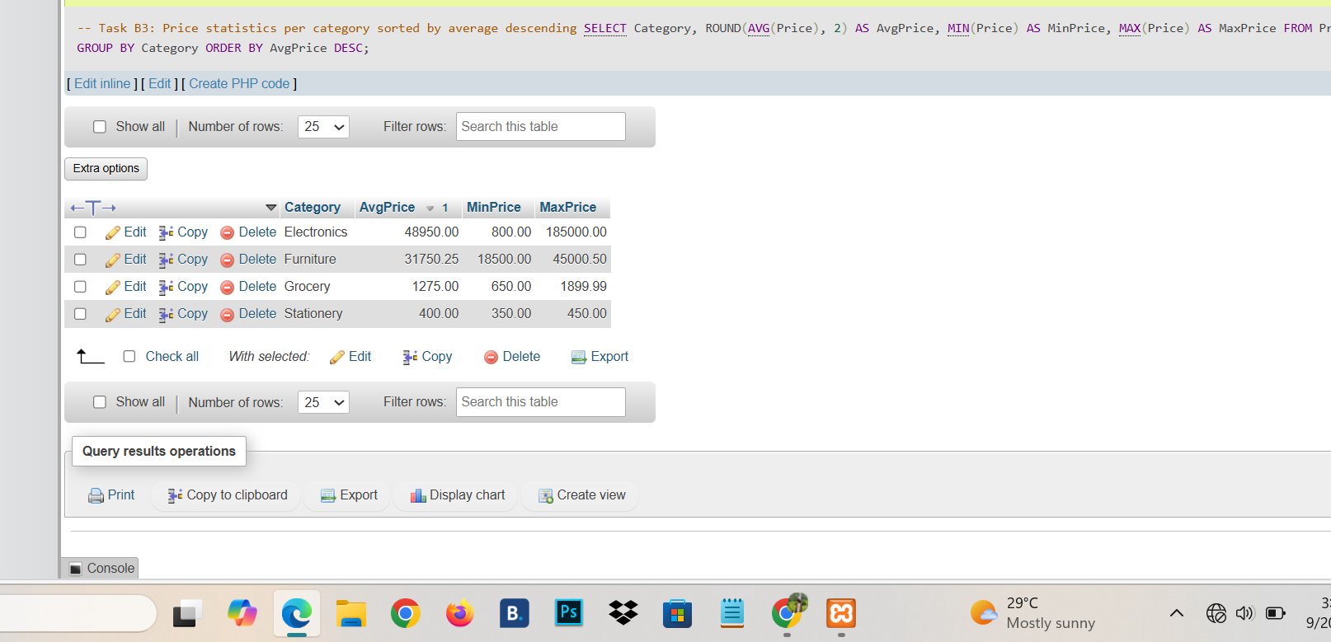
Task B4: Total stock quantity per category. Sort by total descending.
SELECT Category, SUM(StockQty) AS TotalStock FROM Product GROUP BY Category ORDER BY TotalStock DESC;
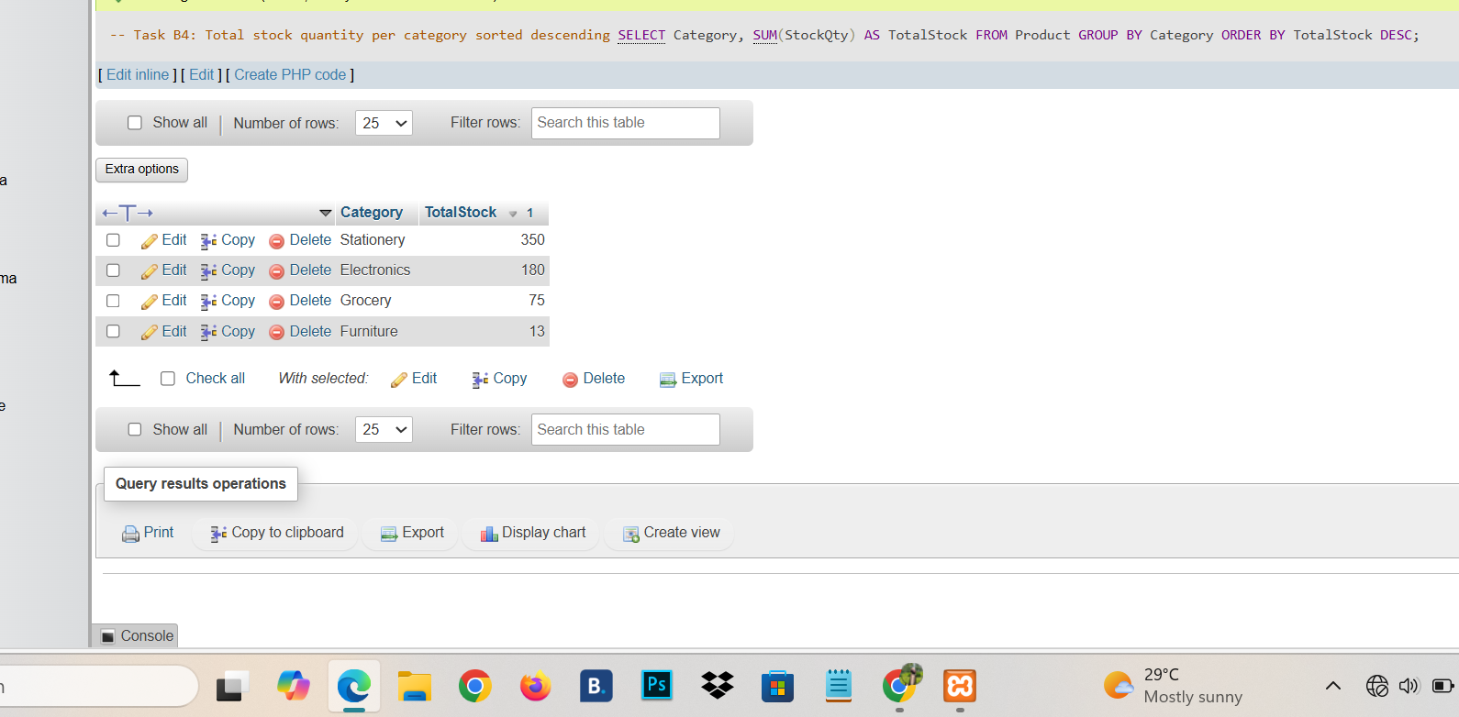
Task B5: Number of orders placed in each year. Show Year and NumOrders, sorted by year.
SELECT YEAR(OrderDate) AS Year, COUNT(*) AS NumOrders FROM OrderItem GROUP BY YEAR(OrderDate) ORDER BY Year;
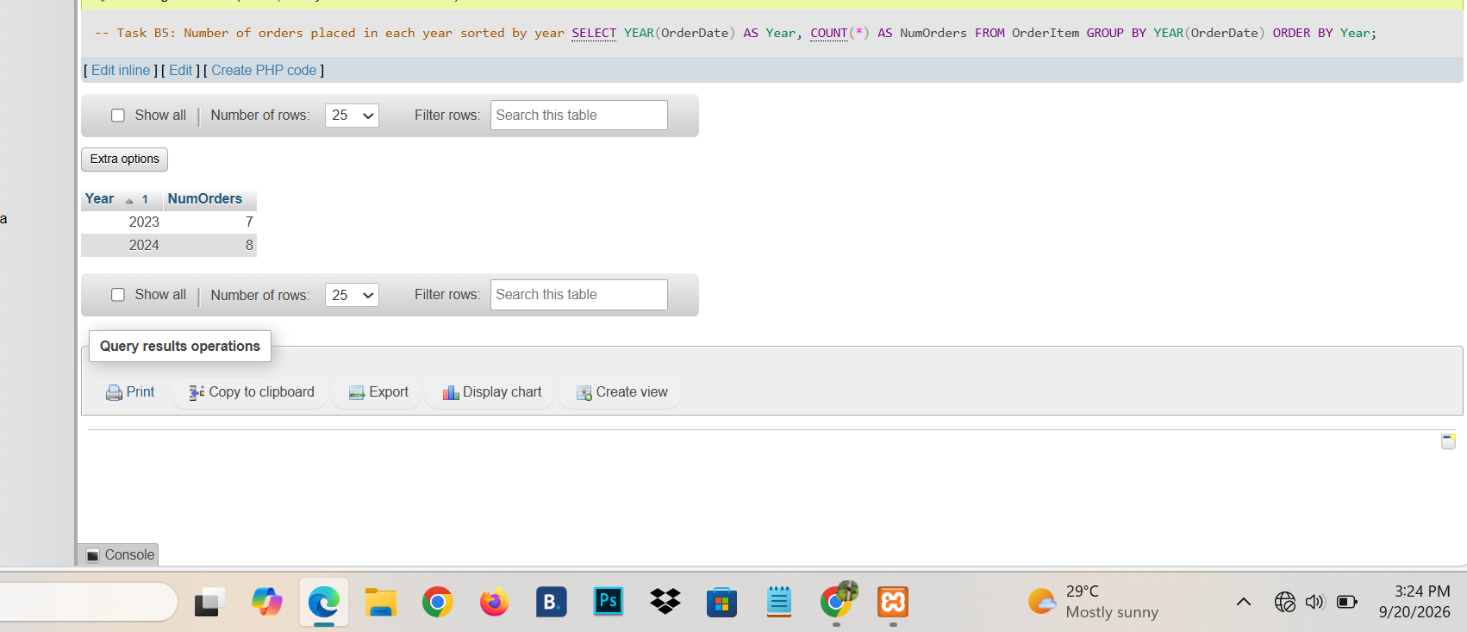
Task B6: Number of orders placed each month of 2024. Show Month (1–12) and NumOrders, sorted by month.
SELECT MONTH(OrderDate) AS Month, COUNT(*) AS NumOrders FROM OrderItem WHERE YEAR(OrderDate) = 2024 GROUP BY MONTH(OrderDate) ORDER BY Month;
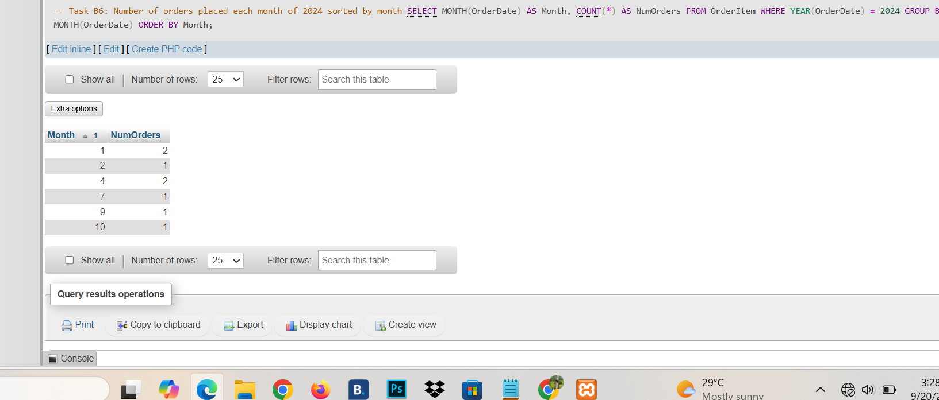
Task B7: Find product categories where the average price is greater than 5,000.
SELECT Category, AVG(Price) AS AvgPrice FROM Product GROUP BY Category HAVING AVG(Price) > 5000;
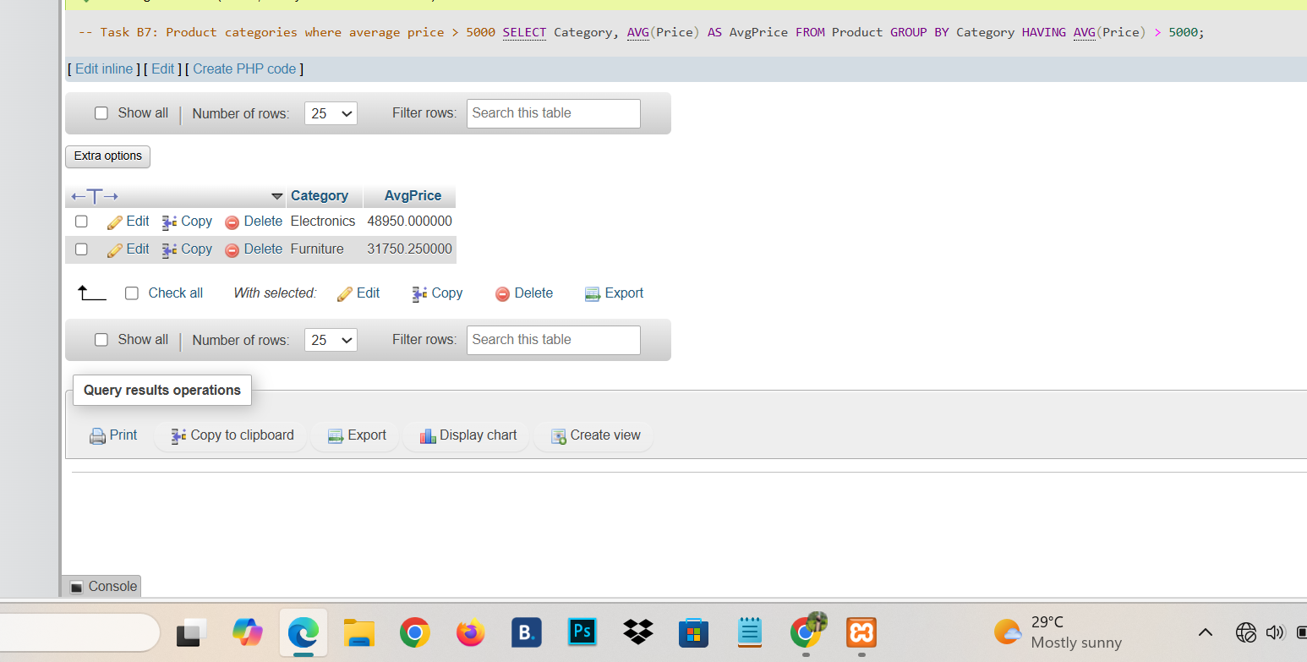
Task B8: Find cities with more than 1 customer (exclude NULL city).
SELECT City, COUNT(*) AS NumCustomers FROM Customer WHERE City IS NOT NULL GROUP BY City HAVING COUNT(*) > 1;
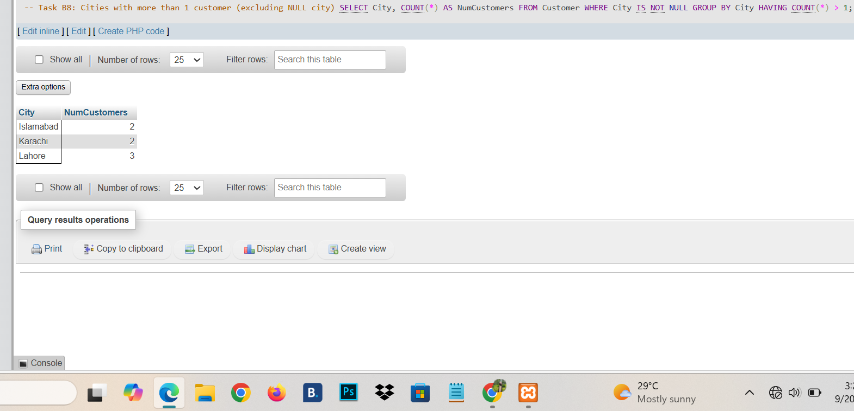
Task B9: For each customer, count how many orders they have placed. Include customers with zero orders.
SELECT c.CustName, COUNT(o.OrderID) AS NumOrders
FROM Customer c LEFT JOIN OrderItem o ON c.CustID = o.CustID
GROUP BY c.CustID, c.CustName;
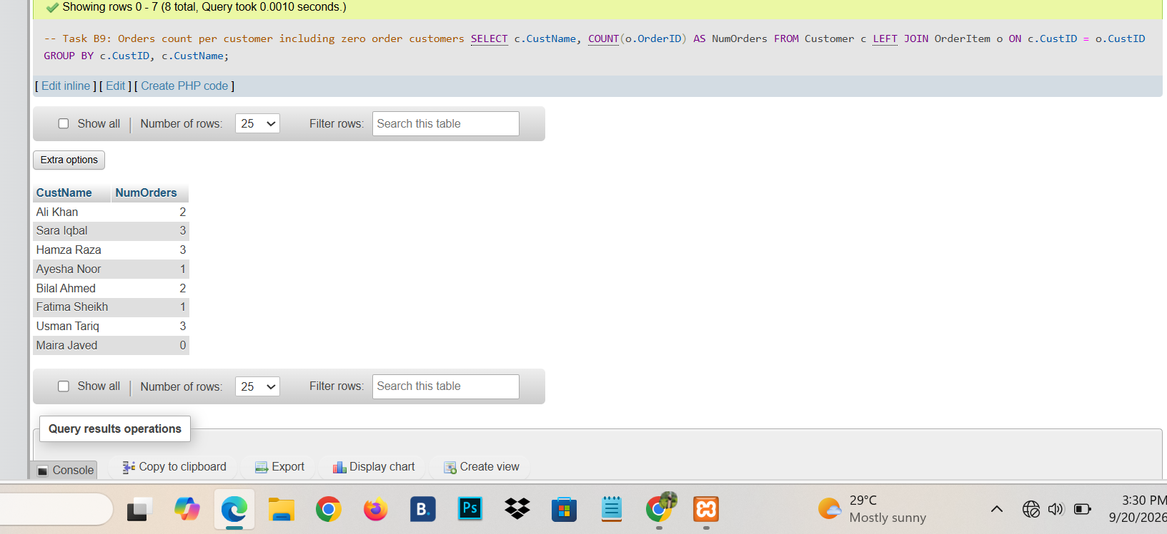
Task B10: Total quantity sold for each product. Include products that have never been sold.
SELECT p.ProdName, COALESCE(SUM(o.Quantity), 0) AS TotalQty
FROM Product p LEFT JOIN OrderItem o ON p.ProdID = o.ProdID
GROUP BY p.ProdID, p.ProdName ORDER BY TotalQty DESC;
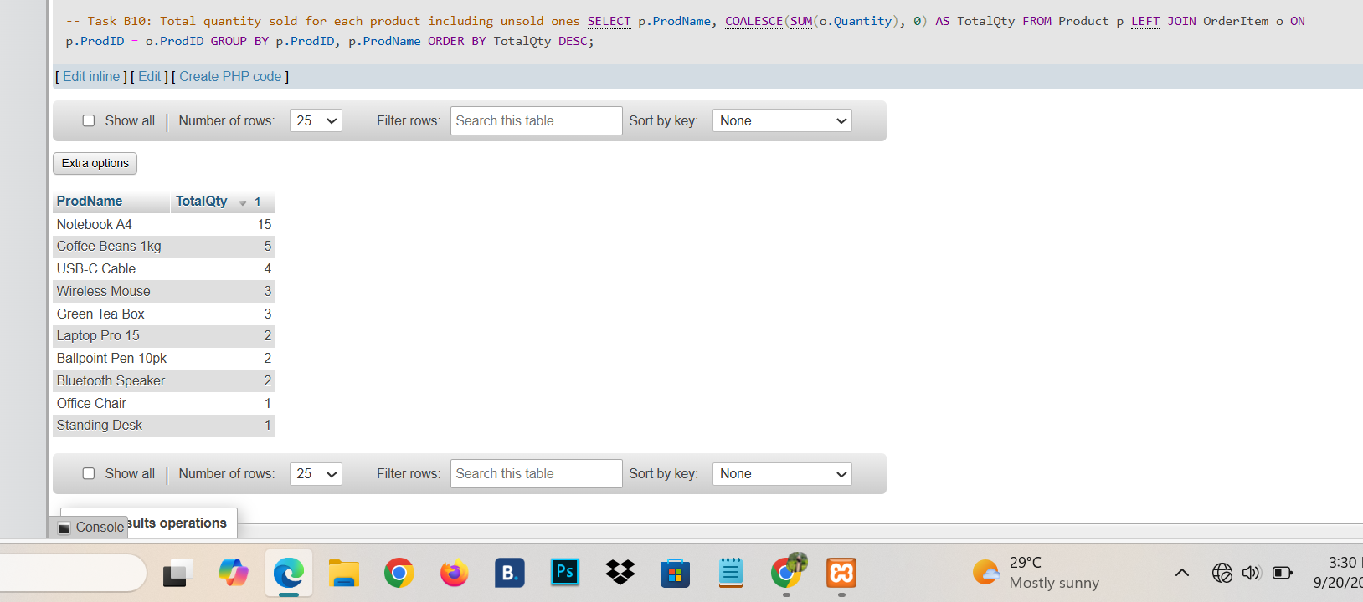
Task B11: Total revenue (Quantity * Price) per product category. Sort by revenue descending.
SELECT p.Category, SUM(o.Quantity * p.Price) AS Revenue
FROM OrderItem o JOIN Product p ON o.ProdID = p.ProdID
GROUP BY p.Category ORDER BY Revenue DESC;
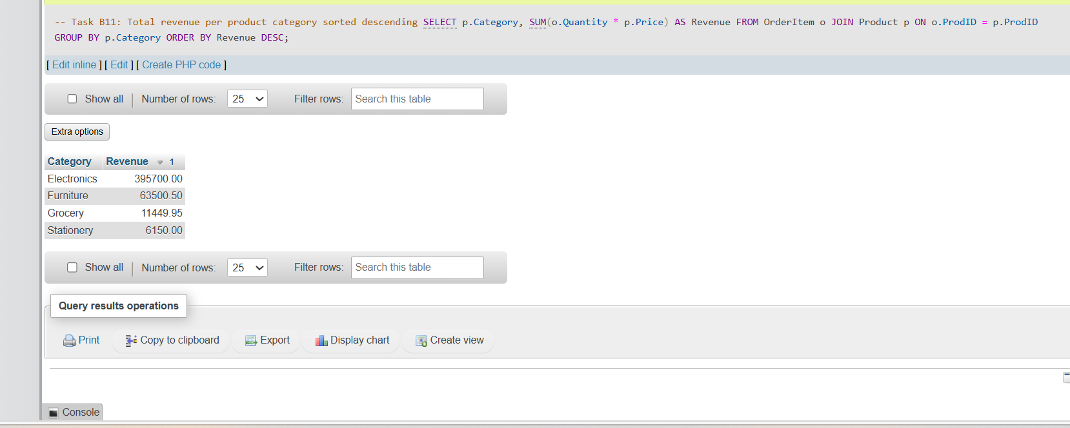
Task B12: For each customer, compute their total spend. Include customers with no orders.
SELECT c.CustName, COALESCE(SUM(o.Quantity * p.Price), 0) AS TotalSpend
FROM Customer c
LEFT JOIN OrderItem o ON c.CustID = o.CustID
LEFT JOIN Product p ON o.ProdID = p.ProdID
GROUP BY c.CustID, c.CustName ORDER BY TotalSpend DESC;
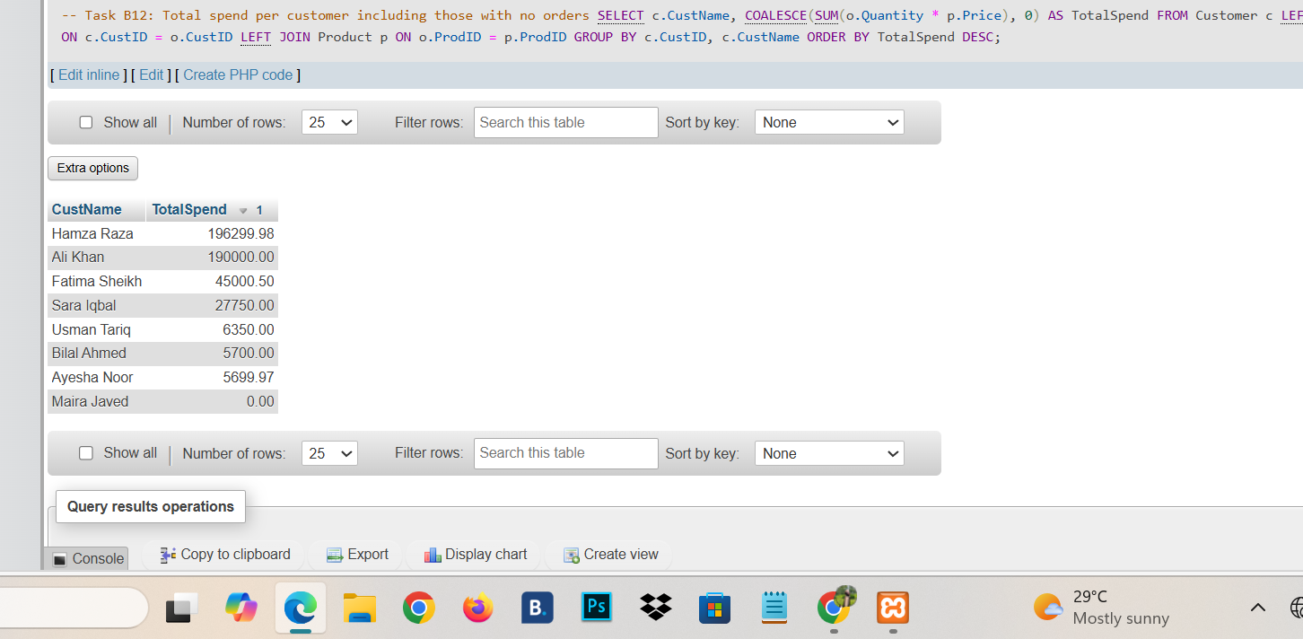
Task B13: List customers whose total spend exceeds 50,000. Show CustName and TotalSpend.
SELECT c.CustName, SUM(o.Quantity * p.Price) AS TotalSpend
FROM Customer c
JOIN OrderItem o ON c.CustID = o.CustID
JOIN Product p ON o.ProdID = p.ProdID
GROUP BY c.CustID, c.CustName HAVING TotalSpend > 50000;
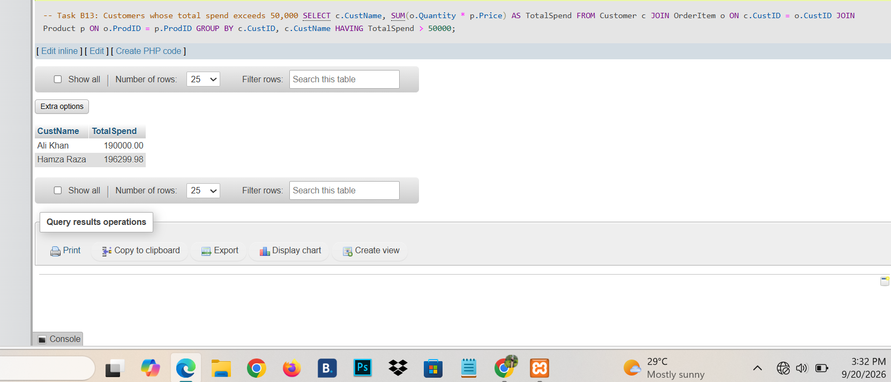
Task B14: For each city, count the number of customers and total revenue generated by them. Include only cities with more than 1 customer.
SELECT c.City, COUNT(DISTINCT c.CustID) AS NumCustomers, SUM(o.Quantity * p.Price) AS TotalRevenue
FROM Customer c
JOIN OrderItem o ON c.CustID = o.CustID
JOIN Product p ON o.ProdID = p.ProdID
GROUP BY c.City HAVING NumCustomers > 1;
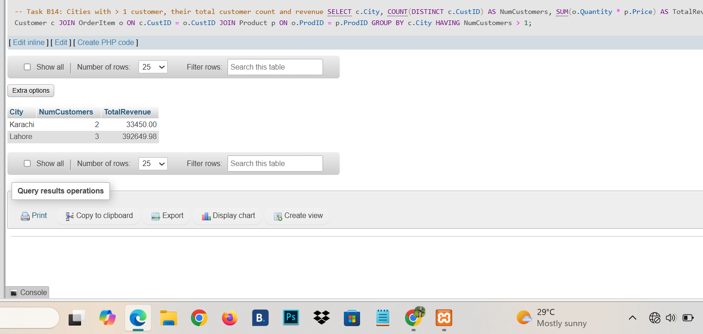
Task B15: Find the top 3 best-selling products by total quantity sold.
SELECT p.ProdName, SUM(o.Quantity) AS TotalQty
FROM OrderItem o JOIN Product p ON o.ProdID = p.ProdID
GROUP BY p.ProdID, p.ProdName ORDER BY TotalQty DESC LIMIT 3;
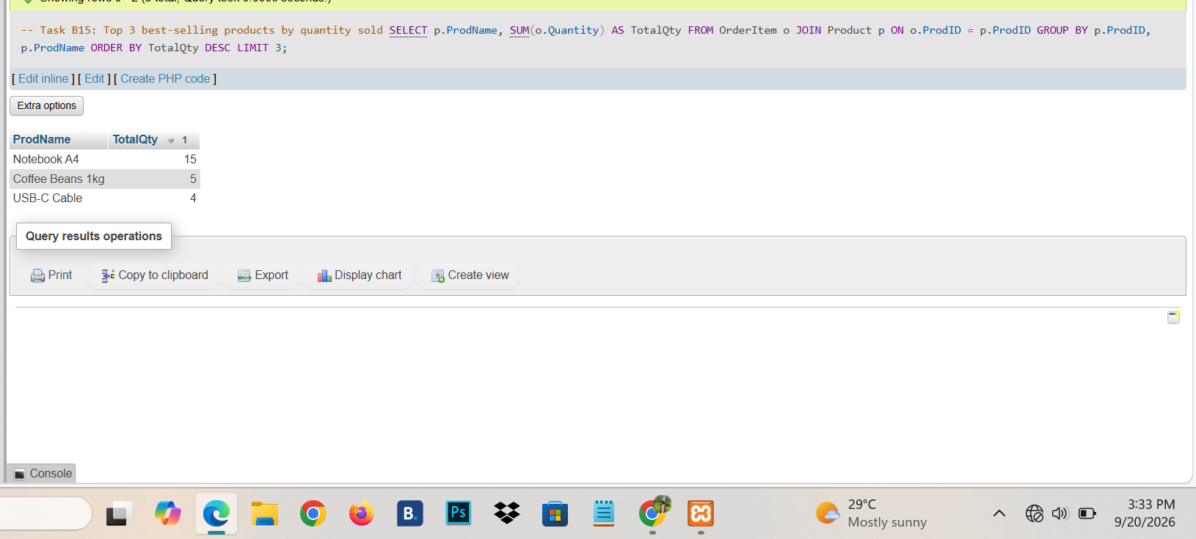
Task B16: For each year, compute the total revenue. Show Year and Revenue, sorted by year.
SELECT YEAR(o.OrderDate) AS Year, SUM(o.Quantity * p.Price) AS Revenue
FROM OrderItem o JOIN Product p ON o.ProdID = p.ProdID
GROUP BY YEAR(o.OrderDate) ORDER BY Year;
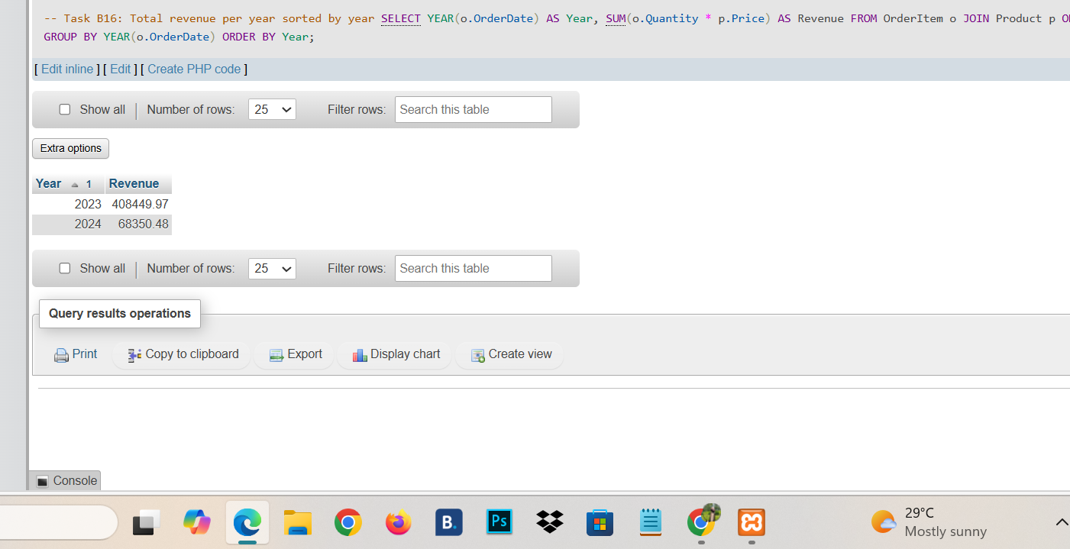
Task B17: Find the average order value (revenue per order).
SELECT ROUND(AVG(OrderValue), 2) AS AvgOrderValue
FROM (
SELECT o.OrderID, SUM(o.Quantity * p.Price) AS OrderValue
FROM OrderItem o JOIN Product p ON o.ProdID = p.ProdID
GROUP BY o.OrderID
) AS OrderTotals;
